*Appealing Machines: Socially Assistive Robotics in Healthcare System*

**Contact Information**

Javier Jesús Macossay-Hernández

University of Southern California – University Park Campus

[macossay@usc.edu](mailto:macossay@usc.edu)

[javiermacossay@hotmail.com](mailto:javiermacossay@hotmail.com)

**Biography of the Author**

Javier Macossay was born and raised in Monterrey, Mexico. He is currently a senior pursuing a Bachelor’s degree in Electrical Engineering at the University of Southern California. His academic goals are to get a Master’s degree in Computer Science and become a Software Engineer.

**Abstract**

Socially Assistive Robotics (SAR) is an area in Engineering where robots are created to support on different tasks depending on the users’ goals. Some of these robots perform assignments for the users or have physical interaction with a patient; however, this article describes social interaction and non-contact therapy sessions [2]. This different approach with patients raises challenges that make this research multidisciplinary by involving broad academic fields, mechanical engineering, machine learning, psychology, education, and kinesiology. This article exposes the results from different studies performed to people with physical disabilities and mental disorders. Moreover, it mentions the technical challenges that the researchers had to overcome to achieve a successful therapy session with short and long term benefits to the patients. This technology aims to make healthcare available to everyone regardless of the economic resources resulting in an enhancement in the quality of life of the patients. Finally, the article discusses the negative effects on patients when robots are similar to human beings.

**Keywords**

* Socially Assistive Robotics
* Uncanny Valley
* Post-stroke Rehabilitation
* Machine Learning
* Autistic Disorder
* Alzheimer
* Joint Attention

**Introduction**

The goal of this article is to present current research that has been done in the field of Socially Assistive Robotics (SAR), the experiments performed to get feedback, the results of these experiments, and the benefits and disadvantages of these new technology. By the end of this article, the reader should be aware of SAR advancements and make a judgment if this new technology can help improve the healthcare system based on its benefits. SAR is a developing field in Engineering that can make rehabilitation accessible to patients with low purchasing power. An assistive robot encourages a patient with a disability to perform a physical task to improve his health [3]. Maja Matarić, Computer Science professor at the University of Southern California, focuses her research on providing rehabilitation to post-stroke and Alzheimer patients, most of them elders. Simultaneously, she performs studies with autistic children [2]. The purpose of working with autistic children is to develop techniques to teach them social skills resulting in adapting to a classroom environment and pursing their academic objectives. In these studies, unexpected challenges are encountered due to the different levels of the patient’s familiarity with technology. Furthermore, the robot is required to adapt to the changing mood of the patients during therapy session (see Fig. 1). The complex interaction with human beings requires researchers to find new applications of machine learning, which is the ability for a computer to adapt in execution time [1]. Unfortunately, human-machine interaction success can be jeopardized if the robots develop physical or emotional characteristics that resemble humans. This hypothesis is referred as “uncanny valley,” which states that human replicas induce revulsion [5].

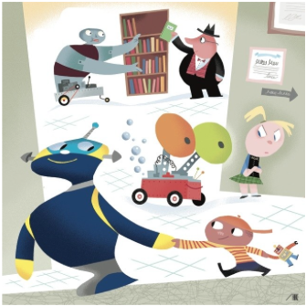

Figure 1: Human-robot interaction.

Source: The New Yorker

**Studies that Support Socially Assistive Robotics Development**

**Post-stroke Rehabilitation**

Strokes result in loss of limb movement. Right after the stroke, neural pathways can be easily reconstructed resulting in disability reduction. Nevertheless, rehabilitation requires a trained professional therapist. Stroke survivors incur significant costs associated with their stroke for the first twelve months. According to the U.S National Library of Medicine, average medication costs $5,392 dollars and average rehabilitation is $11,689 dollars summing into $17,081 dollars. Unfortunately, patients’ economic resources constrain post-stroke rehabilitation due to high cost. Therefore, they cannot recover full limb mobility. As a result, quality of life is drastically reduced and productivity will be affected in their personal and professional lives. The non-contact robot assisted therapy’s goal is to make rehabilitation accessible to patients.

In the case of post-stroke rehabilitation therapy, the robot shows the limb exercises to the patient, and it asks the patient to imitate the movements it is doing with the disabled limb (see Fig. 2). Additionally, the robot will produce a soft beep if the patient performs the exercises correctly. If not done correctly, the SAR will provide constructive feedback. As part of the therapy, the robot encourages the patient to perform specific tasks with the disabled limb to force the patient take advantage of the critical post-stroke period where mobility can be recovered. In addition to offering guided therapy to patients, researchers have noticed that stroke patients are highly motivated and maintain a positive attitude through the therapy sessions when a robot encourages them [6]. In addition to post-stroke rehabilitation, SAR is used to encourage mental activity in young children and elderly people.



Figure 2: Post-stroke rehabilitation.

Source: Youtube

**Alzheimer Patients**

Alzheimers is a chronic disorder that causes problems with memory, thinking, and behavior. People who have this disorder and do not perform mental activity will suffer greater memory loss. Moreover, this disorder primarily affects senior citizens. SAR applies interactive methodologies to strengthen patients’ memory. In contrast with studies performed with post-stroke patients, robots that are programmed to interact with Alzheimer patients encourage mental tasks.

One of the approaches to support mental activity is making the robot sing and ask the patient to guess the name of the song. The robot gives hints to the patient to make the session more interactive. This methodology has given positive results because researchers have seen that patients engage in the session and start signing with the robot. In addition to signing, the robot has two buttons, one on each shoulder, and requests the patient to press a specific button. If the patient presses the correct button, the robot recognizes the patient’s achievement. After six months of this study, patients improved their performance in recognizing songs and pressing the right button.

Researchers performed a similar study using a computer screen instead of the robot. As a result, the patient was not engaged in the experiment and lost interest in a short amount of time. The lack of attention resulted in spending more time to identify the song. Also, the patient was given a set of buttons and, as expected, it took longer to press the correct button [2].

**Autistic Children**

Children with autistic disorders have different levels of joint attention, defined as the ability to share interests and information with other individuals. Therefore, studies in SAR are being performed to understand how to enable this ability and reduce the effects of autism disorders in the long term. Developmental challenges can be mitigated in a classroom context with the assistance of SAR. Moreover, academic performance and social life can be enhanced if teamwork and communication skills are well developed in an early life stage.

In a study performed at the Children’s Hospital of Los Angeles, a robot is used to build children’s joint attention. In this study, the robot produces soft beeps and nods its head to encourage the patient to move closer. Additionally, when the young child moves away from it, the robot tilts its head to simulate discouragement and sadness. Then, the robot makes a hand gesture to encourage the child to move closer (see Fig. 3). As the robot encourages the patient, it simultaneously blows bubbles from its torso. In one of these studies, the patient’s mother convinced the patient to press one of the robot’s buttons, which are located on each shoulder. The child followed the instructions and, consequently, the robot blew a stream of bubbles. Then, the patient laughed while looking at its mother. Thus, SAR therapies for children with autistic disorders lead to a more engaging session and a positive outcome [2]. Two quantitative results that support SAR implementation are 22.84% increase of the patient’s total speech per session and 27.38% increase of total child-robot interaction per session.

In order to have a positive outcome with stroke survivors, autistic children, and Alzheimer patients, the robot needs to adapt to the patient’s personality and mood to keep the patient motivated through the therapy session. For example, an extrovert person with a positive mood will not become involved with a robot that does not talk regularly. However, if the robot makes constant jokes and speaks with the extrovert patient, the patient will feel more comfortable in the rehabilitation session. Predetermining the robot’s mood and personality will not yield to a successful therapy session. Patients are human beings with constantly changing mood, so the researchers needed to find a solution for this changing variable in the human-computer interaction through machine learning [2].

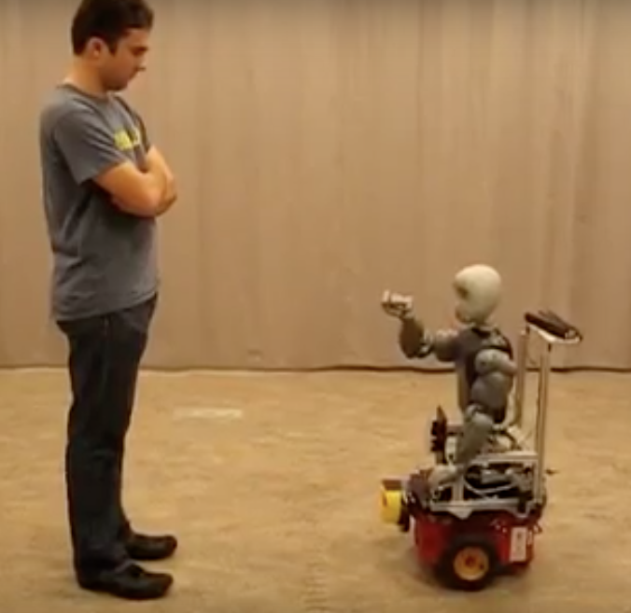

Figure 3: The robot making a hand gesture to the user in a laboratory trial.

Source: Youtube

**Machine Learning to Adapt Robots in Runtime**

Machine learning is a sub-area of artificial intelligence that enables computers to learn and improve user experience without being explicitly programmed (see Fig. 4). In this context, it is the capacity of the robot to adapt to the changing mood of a human being [4]. On the technical level, the robot uses a multidimensional scaling to select features, personality, and mood of the robot [2]. This multidimensional scaling can also be described as a database where the robot can choose the way it will approach the patient. The robot will keep track of the patient’s average response time, average time to select the answer, and percentage of right answers to understand the level of motivation of the patient. Machine learning is a process of making constructive self-criticism resulting in adding human features to the robot. Nonetheless, the patient will be uncomfortable to interact with the robot if it has a disproportionate amount of human features due to the “uncanny valley” effect [5].



Figure 4. Source: Toptal

**The “Uncanny Valley”**

In Robotics, the “uncanny valley” is a term used to describe an eerie sensation when a robot humanoid resembles a human being in physical and personality aspects. Masahiro Mori, a robotics professor at the Tokyo Institute of Technology, hypothesized that a person’s response to a humanlike robot changes from affinity to revulsion as it attempted to attain a realistic appearance (see Fig. 5) [5]. Moreover, Mori derived this term from Sigmund Freud’s essay “The Uncanny”. In his essay, he mentions the existence of an effect of objects that seem both familiar and foreign can cause attraction and repulsion [2]. In the SAR context, the patients will engage with a robot if it has a humanoid shape. However, if the robot has realistic human characteristics, skin, hair, eyes, and a realistic personality, the patient is going to feel repulsion towards the robot, because it will produce a sensation of talking to a quasi-human being.

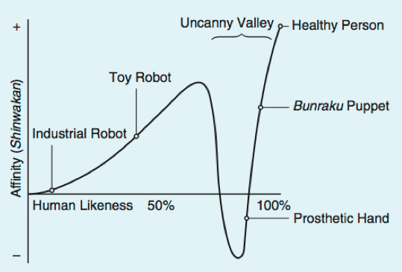

Figure 5: According to Mori, this is the relation between human likeness of a robot and the perceiver’s affinity for the robot.

Source: “The Uncanny Valley” by Masahiro Mori

**Conclusion**

SAR has the potential to improve healthcare by decreasing the cost of therapy. Moreover, trained professionals in rehabilitation medicine can use the robots as assistants. Different studies with post-stroke patients, Alzheimer patients, and children with autistic disorder have shown that SAR is successful in their short and long term goals [2]. In addition, this success requires a significant amount of technical work where artificial intelligence is used to make the robot more humanlike [4]. Nevertheless, affinity with humanoid robots can be drastically reduced if they attempt to have realistic human characteristics [5]. The only factor that is missing to make this technology available to everyone is the mass production. Future work on this field is to keep performing more studies where different methodologies with SAR will be implemented. Furthermore, extensive research in SAR is also branching into exploring different teaching methodologies for autistic children. Hopefully this technology will become available to everyone because it will help close the gap between economic resources and quality of life.

**References**

[1] J. Greczek, E. Short, C. Clabaugh, K. Swift-Spong, and M. Matarić, “Socially Assistive Robotics for Personalized Education for Children”, In *AAI Fall Symposium Series: Artificial Intelligence and Human-Robot Interaction (AI-HRI)*. Arlington, VA, USA. November 12-15.

[2] J. Groopman, “Robots that Care: Advances in technological therapy,” *The New Yorker: Medical Dispatch*, pp. 1-17, Nov. 20, 2009. <http://www.newyorker.com/magazine/2009/11/02/robots-that-care>

[3] J. Stewart, “Ready for the robot revolution?,” *BBC News: Technology*, pp. 1-10, Oct. 3, 2011. < http://www.bbc.com/news/technology-15146053>

[4] A. Tapus, M. Matarić, and B. Scassellati, “The Grand Challenges in Socially Assistive Robotics,” In *IEEE Robotics & Automation Magazine*, vol. 14, no. 1, pp. 35-42, Mar. 2007.

[5] M. Mori, “The Uncanny Valley,” *Energy*, vol. 17, no. 4, pp. 33-35, 1970 (in Japanese).

[6] M. Matarić, J. Eriksson, D. Feil-Seifer, and C. Winstein (2007, Feb 19). *Socially assistive robotics for post-stroke rehabilitation* [Online]. Available: https://jneuroengrehab.biomedcentral.com/articles/10.1186/1743-0003-4-5